An International Journal

[**Life Science Journal**](http://www.lifesciencesite.com/lsj)

Acta Zhengzhou University Overseas Edition

(*Life Sci J*)

ISSN 1097-8135 (print); ISSN 2372-613X (online), Monthly

Volume 22 - Number 5 (Cumulated No. 172), May 25, 2025.

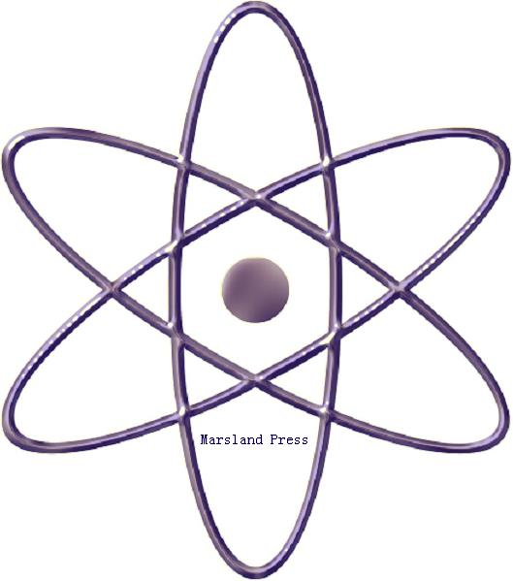

**Marsland Press**

**310 West 18th Street, New York, NY 10011, USA**

[**http://www.lifesciencesite.com**](http://www.lifesciencesite.com)

[**http://www.sciencepub.net**](http://www.sciencepub.net)

[**lifesciencej@gmail.com**](mailto:lifesciencej@gmail.com)

[**editor@sciencepub.net**](mailto:editor@sciencepub.net)

**718-404-5362**

**Life Science Journal: ISSN 1097-8135 (print); ISSN 2372-613X (online); Monthly**

**Life Science Journal**

**Acta Zhengzhou University Oversea Version**

**(*Life Sci J*)**

**Life Science Journal,** the Acta Zhengzhou University Oversea Version, is an international journal with the purpose to enhance our natural and scientific knowledge dissemination in the world under the free opinion/idea publishing principle. The journal is calling for papers from all the world. All the valuable papers or reports that are related to life sciences - in their broadest sense - are welcome. Other academic articles that are only certain relevant but are of high quality will also be considered and published. Papers submitted could be reviews, objective descriptions, research reports, opinions/debates, news, letters, and other types of writings. All submitted manuscripts will be sent for external peer review and processed the editorial work. After the peer review, the journal will make the best efforts to publish the accepted valuable articles as soon as possible. Let's work together to disseminate our research results and our opinions/ideas.

Life Science Journal - Acta Zhengzhou University Overseas Edition, ISSN 1097-8135 (print); ISSN 2372-613X (online)

Marsland Press / Zhengzhou University

310 West 18th Street, New York, NY 10011, USA

100 Kexue Avenue, Zhengzhou, Henan 450001, China

<http://www.lifesciencesite.com>; <http://www.sciencepub.net>

[lifesciencej@gmail.com](mailto:lifesciencejournal@gmail.com); [editor@sciencepub.net](mailto:editor@sciencepub.net)

718-404-5362; 347-321-7172

ISSN 1097-8135



© 2025 Marsland Press / Zhengzhou University